1
Hereditary Cancer Genetic Testing with Genetic Counselling
Payment Authorization Form
(To be completed and signed by the patient)
For private pay samples, please send this credit card payment form with the laboratory requisition and sample to:
All provinces & territories
LifeLabs
Attn: Specimen Management
37 Voyager Court
Toronto, ON
M9W 4Y2

TEST SELECTED

- BRCA1/2 Screen + Genetic Counselling $630.00
- Breast Cancer Panel + Genetic Counselling $998.00
- Breast/Gynecologic Cancer Panel + Genetic Counselling $998.00
- Colorectal Cancer Panel + Genetic Counselling $998.00
- Prostate Cancer Panel + Genetic Counselling $998.00
- Hereditary Cancer Panel + Genetic Counselling $998.00

PLEASE PRINT

Last Name | First Name |  |  | Initial
Birth Date (dd/mm/yyyy) | Phone Number
E-mail
Address
City |  | Province | Postal Code

- Yes, please mail me a copy of my receipt to the above address

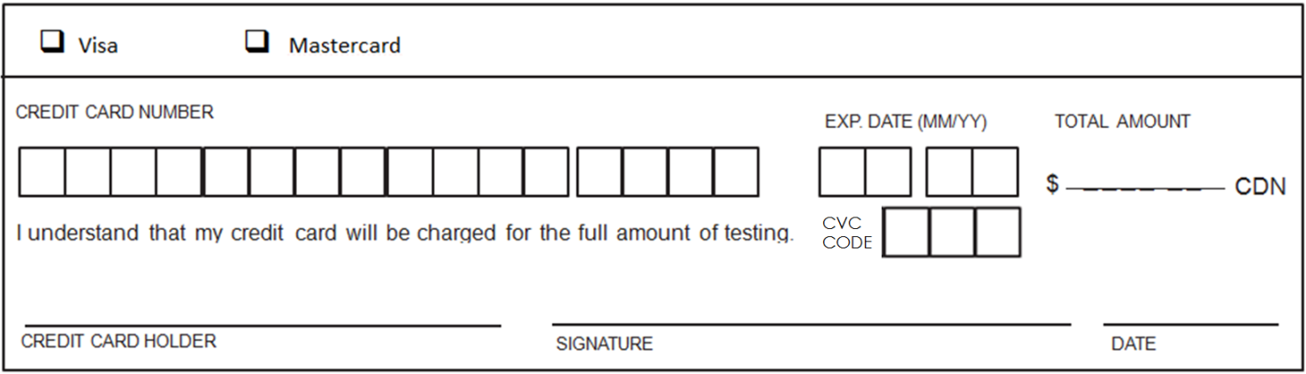
PAYMENT

For more information: 1-844-363-4357 - Ask.Genetics@LifeLabs.com - www.lifelabsgenetics.com
BRCA1/2 credit card paymt form Nov 2019 v5

